**Lab - Encrypting and Decrypting Data using a Hacker Tool**

**Objectives**

**Part 1: Create and Encrypt Files**

**Part 2: Recover Encrypted Zip File Passwords**

Part 1: Create and Encrypt Files In this part, you will create a few text files that will be used to created encrypted zip files in the next step.

Step 1: Create text files.

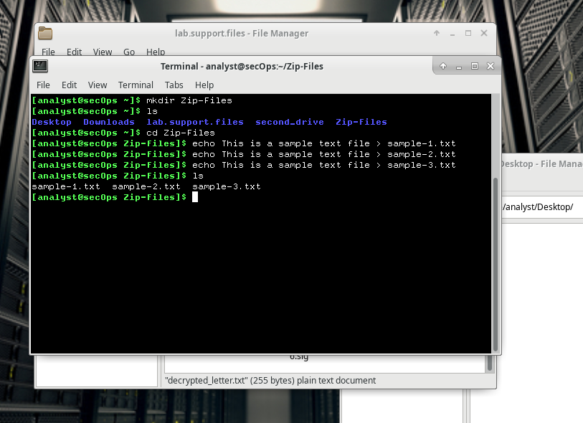

Sample-1,2,3 text files was created in Zip-Files folder.

Step 2: Zip and encrypt the text files.

1. Creating Zip files

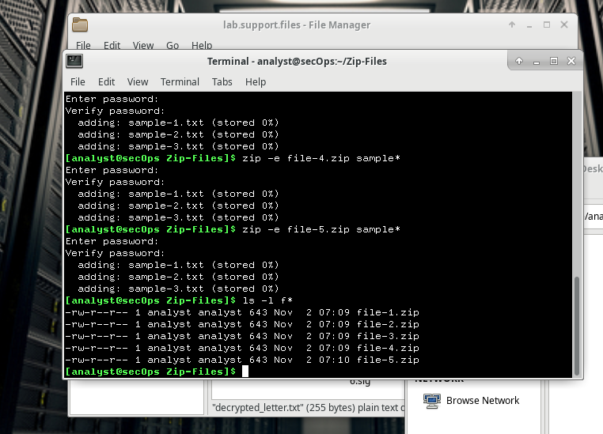

Creating Zip files 1,2,3,4,5 with passwords B,R2,0B1,Y0Da,C-3P0

1. Unziping by wrong passwords

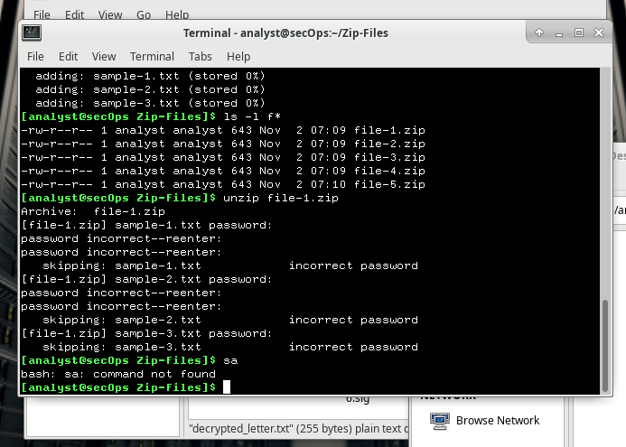

Part 2: Recover Encrypted Zip File Passwords

1. Cracking file-1.zip by brute-force method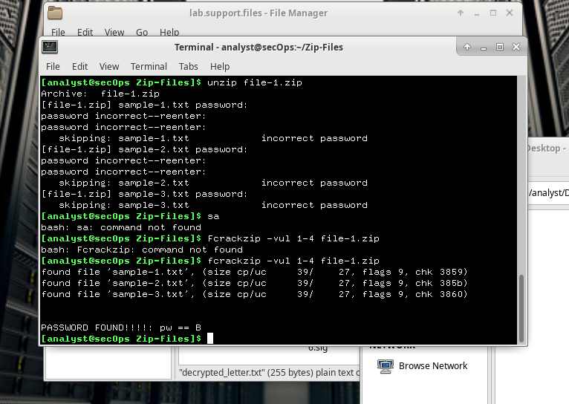

**How long does it take to discover the password?**

Less than 1 second

1. Recover file-2.zip

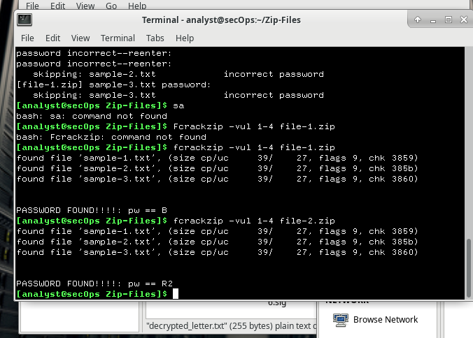

**How long does it take to discover the password?**

As in previous it was less than 1 second

1. Recover file-3.zip

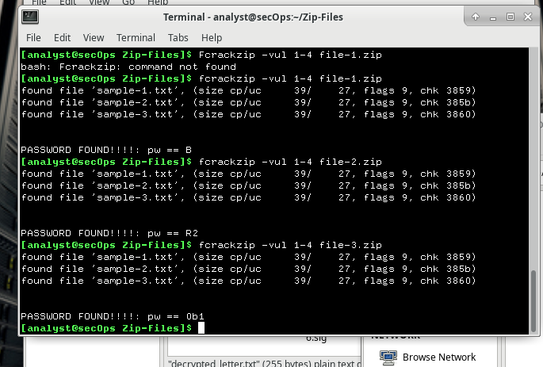

**How long does it take to discover the password?**

It also responded immediately, about second or less

1. Recover file-4.zip

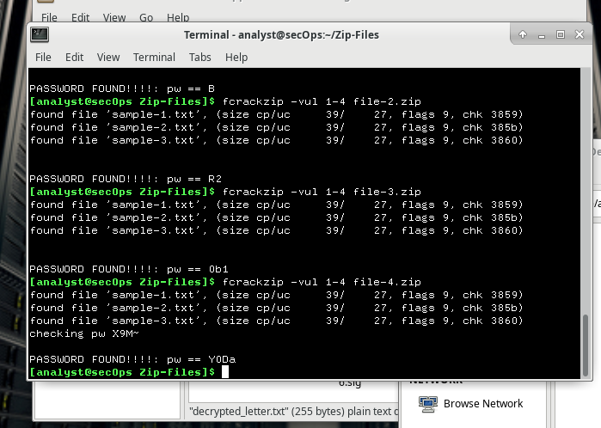

**How long does it take to discover the password?**

Duration about 4-5 seconds.

1. Recover file-5.zip

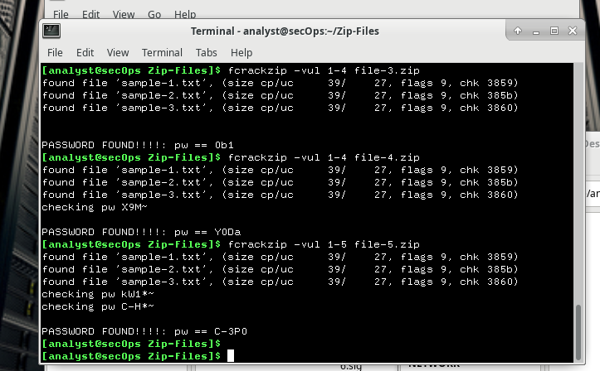

**How long does it take to discover the password?**

Duration about 1 min 54seconds.

1. Recover file-6.zip

**How long do you think it would take fcrackzip to discover a 6-character password?**

May be it will take 2.5-3 hour

1. **How long does it take fcrackzip to discover password?**

Duration 6 hours 3 mins

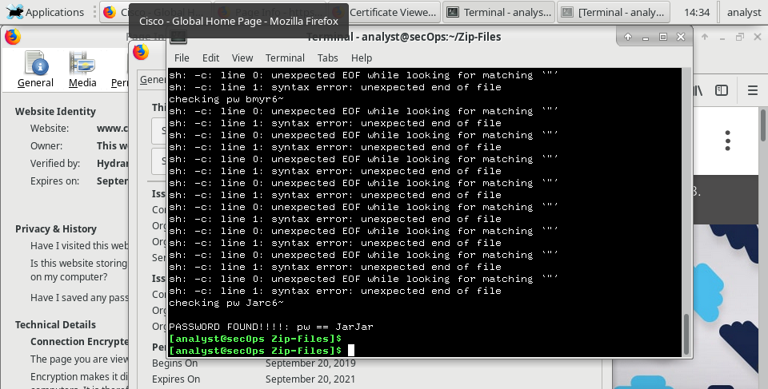

**How long would you recommend a password needs to be for it to be secure?**

As long as the password is at least 12-15 characters long